**WEEK 6**

**Exercise 1:**

**In cmd:**

npx create-react-app myfirstreact cd myfirstreact

code .

**App.js**

import React from 'react'; function App() {

return (

<div>

<h1>Welcome to the first session of React</h1>

</div>

);

}

**In Terminal: npm start**

**Output:**

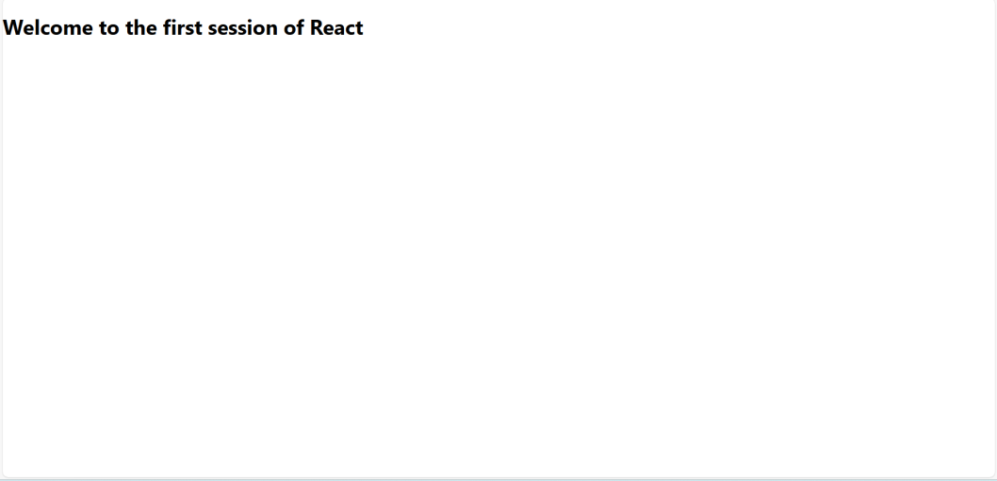

**Exercise 2:**

**In components Home.js**

import React, { Component } from 'react'; class Home extends Component { render() {

return <h2>Welcome to the Home page of Student Management Portal</h2>;

}

}

**About.js**

import React, { Component } from 'react'; class About extends Component { render() {

return <h2>Welcome to the About page of the Student Management Portal</h2>;

}

}

export default About;

**Contact.js**

import React, { Component } from 'react'; class Contact extends Component { render() {

return <h2>Welcome to the Contact page of the Student Management Portal</h2>;

}

}

export default Contact;

**App.js**

import React from 'react';

import Home from './Components/Home'; import About from './Components/About'; import Contact from './Components/Contact'; function App() {

return (

<div className="App">

<Home />

<About />

<Contact />

</div>

);

}

export default App;

**In terminal: npm start Output:**

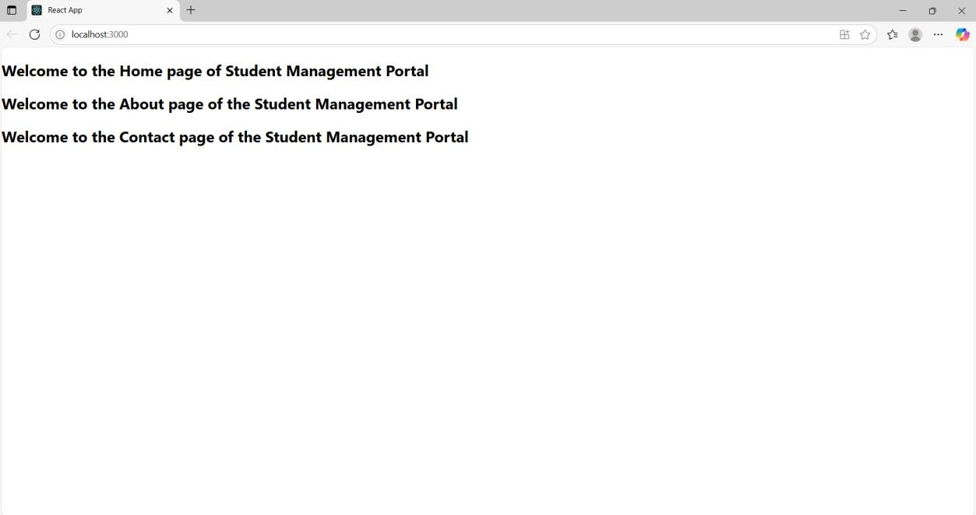

**Exercise 3:**

**In Terminal:**

npx create-react-app scorecalculatorapp cd scorecalculatorapp

code .

**In components**

**CalculateScore.js**

import React from 'react';

import '../Stylesheets/mystyle.css'; function CalculateScore(props) {

const average = props.total / props.goal; return (

<div className="score-box">

<h2>Student Score Details</h2>

<p><strong>Name:</strong> {props.name}</p>

<p><strong>School:</strong> {props.school}</p>

<p><strong>Total Marks:</strong> {props.total}</p>

<p><strong>Goal:</strong> {props.goal}</p>

<p className="result"><strong>Average Score:</strong> {average.toFixed(2)}</p>

</div>

);

}

export default CalculateScore;

**In Stylesheet Folder Mystyle.css**

.score-box {

border: 2px solid #4CAF50; border-radius: 10px; padding: 20px;

margin: 40px auto; width: 60%;

background-color: #f9f9f9; font-family: Arial, sans-serif;

box-shadow: 0px 4px 10px rgba(0, 0, 0, 0.1);

}

.score-box h2 { color: #4CAF50; text-align: center;

}

.score-box p { font-size: 16px; margin: 10px 0;

}

.result {

color: #d9534f; font-weight: bold;

}

**App.js**

import React from 'react'; import './App.css';

import CalculateScore from './Components/CalculateScore'; function App() {

return (

<div className="App">

<CalculateScore name="Naren karthick"

school="marco Public School" total={430}

goal={4}

/>

</div>

);

}

export default App;

In terminal: npm start

**Output:**

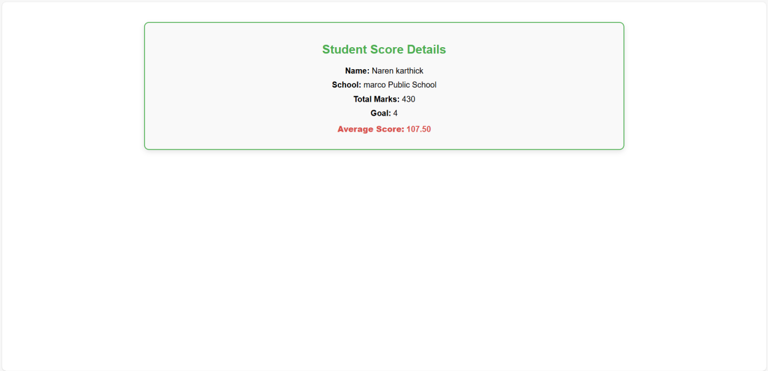

**Exercise 4:**

**In Terminal:**

npx create-react-app blogapp cd blogapp

code .

**In components Post.js**

import React from 'react'; function Post({ title, body }) { return (

<div style={{ border: "1px solid #ccc", padding: "10px", marginBottom: "10px" }}>

<h3>{title}</h3>

<p>{body}</p>

</div>

);

}

export default Post;

**Posts.js**

import React, { Component } from 'react'; import Post from './Post';

class Posts extends Component { constructor(props) { super(props);

this.state = { posts: [], hasError: false,

};

}

loadPosts = async () => { try {

const response = await fetch('https://jsonplaceholder.typicode.com/posts'); const data = await response.json();

this.setState({ posts: data });

} catch (error) { console.error('Fetch error:', error); this.setState({ hasError: true });

}

};

componentDidMount() { this.loadPosts();

}

componentDidCatch(error, info) { this.setState({ hasError: true });

alert("Something went wrong: " + error.message);

}

render() {

if (this.state.hasError) {

return <h2>Something went wrong while loading posts.</h2>;

}

return (

<div>

<h2>Blog Posts</h2>

{this.state.posts.slice(0, 10).map(post => (

<Post key={post.id} title={post.title} body={post.body} />

))}

</div>

);

}

}

export default Posts;

**App.js**

import React from 'react'; import './App.css';

import Posts from './Posts'; function App() {

return (

<div className="App">

<h1>Blog Application</h1>

<Posts />

</div>

);

}

export default App;

In the terminal: npm start

**Output:**

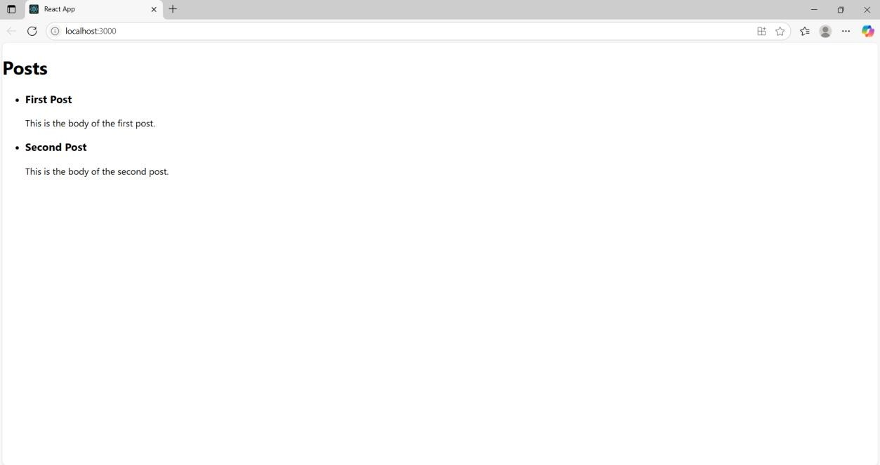

**Exercise 6:**

**In Terminal:**

npx create-react-app TrainersApp cd TrainersApp

code .

**In src:**

**Trainer.js**

class Trainer {

constructor(trainerId, name, email, phone, technology, skills) { this.trainerId = trainerId;

this.name = name; this.email = email; this.phone = phone;

this.technology = technology; this.skills = skills;

}

}

export default Trainer;

**TrainersMock.js**

import Trainer from './Trainer'; const trainers = [

new Trainer(1, "John Doe", "[john@example.com"](mailto:john@example.com), "1234567890", "Java", ["Spring", "Hibernate"]),

new Trainer(2, "Jane Smith", ["jane@example.com"](mailto:jane@example.com), "9876543210", "Python", ["Flask", "Django"]),

new Trainer(3, "Michael Brown", "[michael@example.com"](mailto:michael@example.com), "4567891230", "React", ["Hooks", "Redux"])

];

export default trainers;

**In terminal : npm install react-router-dom TrainerList.js**

import React from 'react';

import { Link } from 'react-router-dom'; const TrainerList = ({ trainers }) => { return (

<div>

<h2>Trainers List</h2>

<ul>

{trainers.map(trainer => (

<li key={trainer.trainerId}>

<Link to={`/trainers/${trainer.trainerId}`}>{trainer.name}</Link>

</li>

))}

</ul>

</div>

);

};

export default TrainerList;

**Home.js**

import React from 'react'; const Home = () => { return (

<div>

<h1>Welcome to Cognizant Academy</h1>

<p>Explore trainers and their expertise!</p>

</div>

);

};

export default Home;

**TrainerDetails.js**

import React from 'react';

import { useParams } from 'react-router-dom'; import trainers from './TrainersMock';

const TrainerDetails = () => { const { id } = useParams();

const trainer = trainers.find(t => t.trainerId === parseInt(id)); if (!trainer) return <p>Trainer not found</p>;

return (

<div>

<h2>{trainer.name}</h2>

<p><strong>Email:</strong> {trainer.email}</p>

<p><strong>Phone:</strong> {trainer.phone}</p>

<p><strong>Technology:</strong> {trainer.technology}</p>

<p><strong>Skills:</strong> {trainer.skills.join(', ')}</p>

</div>

);

};

export default TrainerDetails;

**App.js**

import React from 'react';

import { BrowserRouter as Router, Routes, Route, Link } from 'react-router-dom'; import Home from './Home';

import TrainerList from './TrainerList'; import TrainerDetails from './TrainerDetails'; import trainers from './TrainersMock'; function App() {

return (

<Router>

<nav>

<Link to="/">Home</Link> |

<Link to="/trainers">Trainers</Link>

</nav>

<Routes>

<Route path="/" element={<Home />} />

<Route path="/trainers" element={<TrainerList trainers={trainers} />} />

<Route path="/trainers/:id" element={<TrainerDetails />} />

</Routes>

</Router>

);

}

export default App; In terminal: npm start **Output:**



